September Newsletter

Hello Riders, just to let you know of some great fun activities coming up for September 2017! Apart from our normal group lessons on Saturday morning’s, and Tuesday’s at 4.30pm and 6 o’clock, we also have the following:

Sunday 3rd September – 3 Hour Hack
This lovely three hour hack is one not to be missed, spaces will fill up extremely quick so please book in advance to avoid to disappointment. A lovely ride through Royal Leamington Spa and Newbold Comyn, with a cheeky half way pub stop along the way.
£85

Sunday 10th September- Credit Crunch
Another Do Your Own Thing which means an hour and a half riding, do your own thing around our grounds putting into practice what you have been taught. This ride is extremely popular so please book now to avoid disappointment, 10am start.
just £40

Sunday 17th September – Funday
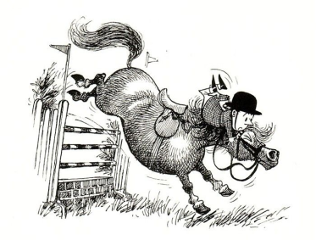
A fun day of riding, with lessons, mini-hacks and gymkhanas whereby you win a rosette, remember to bring your pack lunch. 10am till approx 3pm
Great deal, not to be missed!
ONLY £65!

Sunday 24th September – Fun Clear Round Jumping
Clear round jumping with a twist, 10am start, not a very high course (unless you would like it higher) and you choose your own route, rosettes to be won by all. Approximately 2 and a half hour’s
£70!

To book, or any questions please speak to Janet or a member of staff
01926 494313 or alternatively email janet@warwickriding.co.uk
Don’t forget to ‘like’ us on Facebook: Warwick International School of Riding

