Warwick International School of Riding
February Newsletter
Hello Riders,
February brings valentine’s Month! Just to let you know of some great fun activities coming up for January 2017! Apart from our normal lessons on Saturdays, Tuesdays and our children’s after school riding and stable management lesson (every Tues 4.30pm) we also have the following:

Sunday 5th February- Gallop Races & Chase me Charlie
Need for speed!? Approximately a two hour ride, including a timed race around gallops with few jumps followed by chase me Charlie. £80

Sunday 12th February- Dressage Test
Dressage test for those who have been taking dressage lessons 10am start.
£ Price to be advised
Also we have several horses free for a do your own thing £40

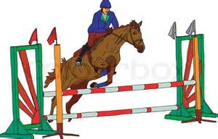
Sunday 19th February - Credit Crunch
Another Do Your Own Thing Ride which means an hour and a half riding just £40.00! You may do your own thing and put into practice what you have been taught. You can go around our grounds - down the bottom, around the gallops and pop over one or two jumps if you wish! This ride is extremely popular so please book now to avoid disappointment. 10am start

Tuesday 21st February - Funday
A fun day of riding, with lessons, mini-hacks and gymkhanas whereby you win a rosette, bring a pack lunch. Great deal, not to be missed, ONLY £65!

Sunday 26th February - 2 Hour Hack
Join us on one of our lovely two hour hacks through the lovely Warwickshire country side; cantering through the open fields and playing around in the stream at the local farm. ONLY £65!

To book or any questions please speak to Janet or a member of staff
01926 494313 or alternatively email janet@warwickriding.co.uk
Don’t forget to ‘like’ us on Facebook: Warwick International School of Riding

