Warwick International School of Riding
November Newsletter
Hello Riders,
This is your friendly riding school just to let you know of some great fun activities coming up for June 2016!
Apart from our normal lessons on Saturdays, Tuesdays and our children’s after school riding and stable management lesson (every Tues 4.30pm) we also have the following:
Sunday 6th November- Horse Day Off

Sunday 13th November- Credit Crunch
Another Do Your Own Thing Ride which means an hour and a half riding just £40.00!
You may do your own thing and put into practice what you have been taught. You can go around our grounds - down the bottom, around the gallops and pop over one or two jumps if you wish! 10am start

Sunday 20th November- 2Hour Hack
A beautiful 2 hour ride around Warwickshire unspoilt countryside. This ride fills up very quickly so book now to avoid disappointment. 10am start £65.00

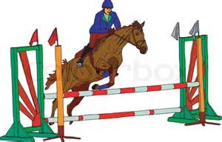
Sunday 27th November- Clear Round Jumping & Chase me Charlie
A fun show jumping course followed by the great chase me Charlie. We ask if you could please dress smart. Rosettes for clear rounds approx 2 hours just £75.00 start at 10am Please book now to avoid disappointment.

To book or any questions please speak to Janet or a member of staff 01926 494313 or alternatively email janet@warwickriding.co.uk

Don’t forget to ‘like’ us on Facebook: Warwick International School of Riding

